**Gala Report/ Awards Ceremony 2020**

The Gala ***was*** scheduled and booked to be held *originally* on **Sat. April 25th *at* Links of Kent**.

***Unfortunately,*** due to unprecedented times, the Gala had to be cancelled because on March 11, 2020 **WHO** announced that the world is *now* dealing with a Pandemic due to **COVID-19.**

Our **Gala Event** was therefore, ***cancelled on March 18, 2020*** in an e-mail communication with Yvonne Hickin, *the Events Co-ordinator at the Links of Kent*, with the understanding that once everything settles down, a new date will *hopefully* be set. No refund was necessary as no deposit was given.

*Unfortunately*, as the COVID situation became very fluid and restrictions were constantly changing, our Gala Committee decided to host an outdoor **Awards Ceremony at Kingston Park** **on September 13, 2020 *(with Plan B as Sunday, September 20th*)** The Shelter provided us with a venue in which **all** COVID Protocols were able to be implemented and followed.

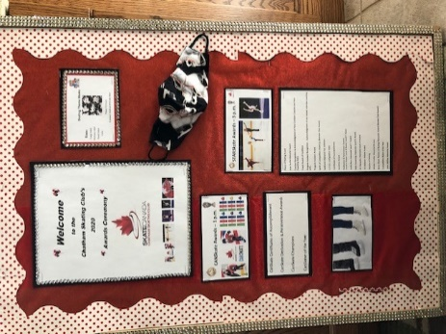 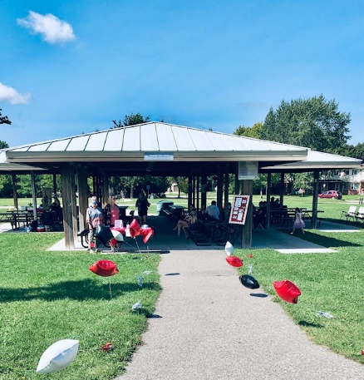 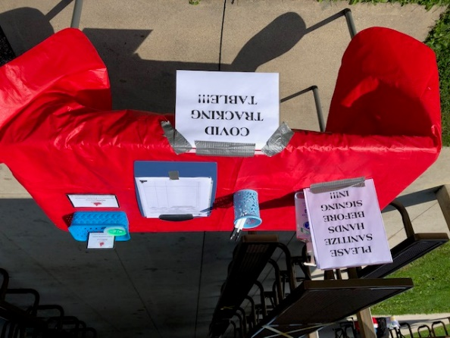

Our **Ceremony Committee** & our **Awards Committee** worked very hard to organize a meaningful & safe Celebration for our Skaters and their families.

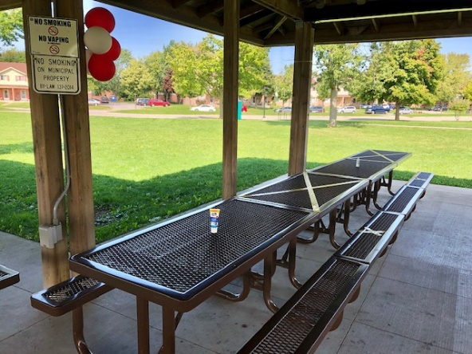 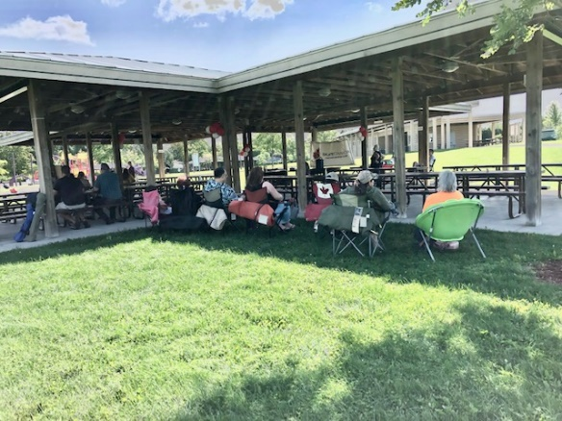

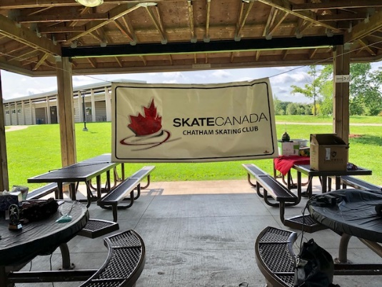 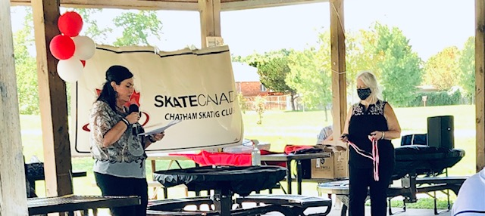

Our President, *Cheryl Ross*, communicated on August 28, 2020 to inform all Chatham Skating Club members, coaches and Board of Directors by email about our Free Outdoor Awards Ceremony. Cheryl clearly stated that all COVID protocols would be carefully followed and she explained that skaters and their families could choose to sit in the shelter at the assigned areas or bring a lawn chair and sit outside the shelter to ensure physical distancing. Wearing masks inside the shelter was highly recommended as well, Cheryl stated clearly that tables were a “*first come, first served*” basis and no food would be allowed in and around the shelter. Cheryl also explained the sign in & tracking system and asked each member to RSVP so numbers could be anticipated. Cheryl concluded her email reminding our families that there would be a Donation Box at our Sign-In table and that donations would be greatly appreciated.

**Shelter #3** *with all 4 sections* (I, J, K & L) was reserved through the City Hall. The Rental Licence allowed us to have this area from 9 a.m. – 6 p.m. for a total cost of $278.79. Having a permit was very important as this would avoid any possible conflicts with the public. A copy of our permit was posted inside the Shelter and Carolynn also had a copy of the permit with her in case any issues needed to be addressed.

Our **Celebration** was divided into **2 separate Award Ceremonies**:

**CanSkate Awards** at 1 p.m. *and* **StarSkate Awards** at 3 p.m.

The 2 separate Awards Ceremonies allowed us to follow COVID Protocol with respect to the limited number of people allowed, ensuring physical distancing and this also allowed our Ceremony Committee members ample time to disinfect the area properly between the two ceremonies. Each family received a program to follow along with the Awards ceremony.

**Awards Ceremony Set Up Details *on* the day of the event:**

* *Marking the floor with yellow tape to indicate the flow of traffic inside the shelter*
* *Marking the spot for the skaters to stand for their picture after picking up their award*
* *Marking off sections of tables with yellow tape to ensure physical distancing*
* *Hanging the Chatham Figure Skating Banner*
* Setting up the PA System *(rented one outdoor speaker & mic from Musical Strings “N” Things for $50.85)*
* *Setting up the easel with Welcome Bulletin Board*
* *Cleaning the floor area & disinfecting all tables inside the Shelter*
* *Setting up Welcome Table with tracking sheets (Skate Ontario’s Chart – Version 3.0 Aug.17 2020), pens, hand sanitizer & Donation Box*
* *Decorating the Shelter Area with balloons to not only give our area a sense of Celebration but also to indicate that all 4 sections have been reserved for our Skating Club’s use*
* *Designating an AWARDS Table (Section J) * Certificates of Accomplishment & PA Certificates were only presented to those skaters that were present at our Awards Ceremony. The PA Certificates were to be kept in a binder & given out at the arena once our Skating Season resumes to those PA’s that were not able to attend the Ceremony\**
* *Setting up Bee Traps … as September is BEE Season … the weather was beautiful & just windy enough to keep the bees away on Sept. 13th! ☺*
* *First Aid Kit was available*

Rhonda Jubenville-Stallaert was our MC for both Award Ceremonies and Karen Andari assisted with placing the awards on the awards table for the skater to pick up. Once the skater picked up his/ her award they were directed to a marked spot to stand for their picture taken by our Photographer, Kelly Meredith.

Overall, it was a very successful, fun and meaningful day that brought a smile to many of our skaters and a little sunshine into our COVID Challenging Times!



**Ceremony Committee:** Carolynn Gregory – Co-ordinator

Cheryl Ross, Suham Doey, Krystal Johnson, Rhonda Jubenville-Stallaert, Jennifer Larson-Cochrane, Kelly Meredith, Charlene Stinson & Kelly Barreirra

**Awards Committe:** Karen Andari – Committee Leader

Cheryl Ross, Rhonda Jubenville-Stallaert, Karine Kearney & Heather MacLeod

**Respectfully submitted,**

**Carolynn Gregory ☺**

**May 2021**